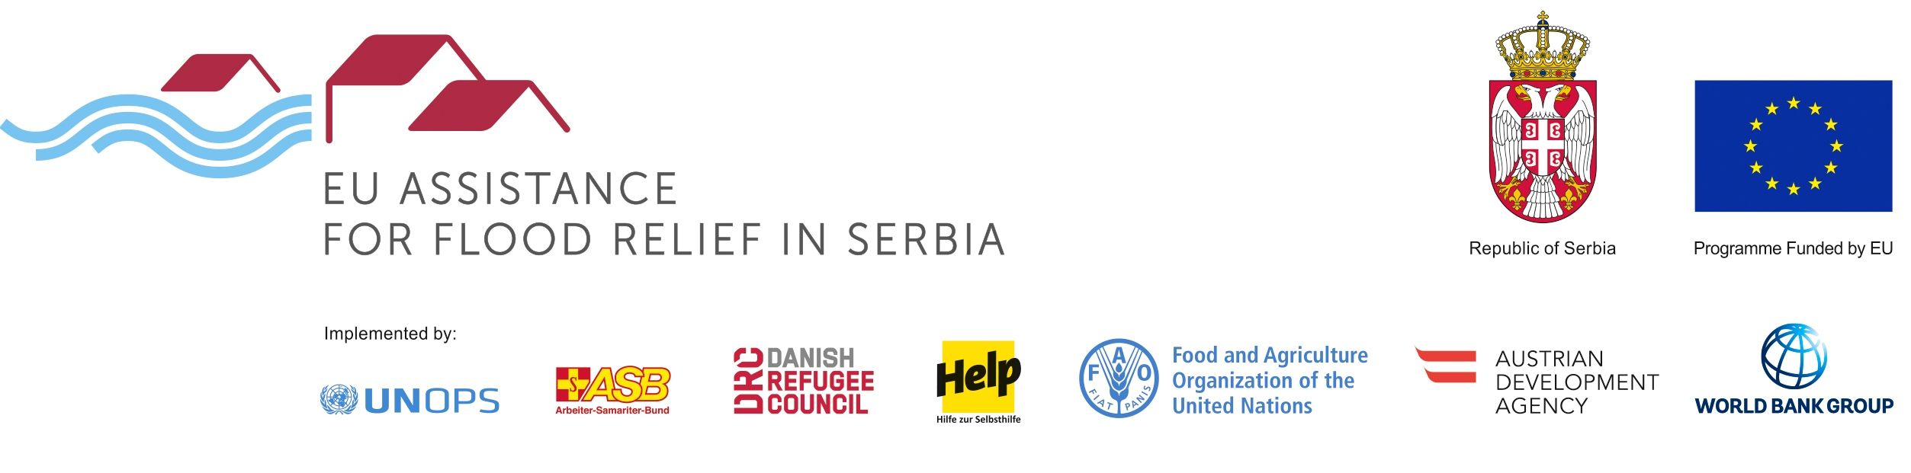

PROGRAMME: REHABILITATION OF FLOOD PROTECTION INFRASTRUCTURE
TENDER: EMERGENCY WORKS TO PROTECT THE CITY OF PARACIN AGAINST FLOODS REFERENCE: RFPI 012 2016

The Austrian Development Agency (acting on behalf of the public water management company Srbijavode as Investor) intends to award a works contract for the regulation and reconstruction of the Crnica river in Paraćin with financial assistance from the European Union. The open tender procedure is conducted pursuant to the provisions of the Austrian Federal Act on Public Procurement (Bundesvergabegesetz).

The official tender notice is published on:
https://www.auftrag.at/eTender.aspx?id=283F6709-614A-465E-BCCE-214A77445EBA&action=show. The tender dossier can be downloaded under this link after registration. Possible additional information, addenda or clarifications shall be published on https://www.auftrag.at/eTender.aspx?id=283F6709-614A-465E-BCCE-214A77445EBA&action=show

Contact Point/further information: WOLF THEISS Rechtsanwälte, Vienna
E-mail: embankments.paracin@wolftheiss.com; Fax: + 43 1 515 10 665354
Location of the works: Paraćin in Serbia
CPV codes: 45246400, 45246000, 45246100 and 45243510
Deadline for submission of tenders: 30 January 2017, 11:00 a.m at WOLF THEISS Rechtsanwälte GmbH & Co KG in Schubertring 6, 1010 Vienna.
Opening of tenders: 30 January 2017, 11:30 a.m. at Wolf Theiss Rechtsanwälte, Schubertring 6, 1010 Vienna, Austria.

